**TECHNICAL REPORT ON PROJECT 6**

**BY**

**ADEGOKE BLESSING TUNMISE**

**VEPH/20B/DA189**

**Task 21B**

**SALES PERFORMANCE ANALYSIS OF COCA-COLA BEVERAGES IN 2020**

OUTLINE

1.     Introduction

2.     Story of Data

3.     Data Splitting

4.     Pre-Analysis

5.     In-Analysis and Insights

6.     Data Visualization

7.     Recommendations and Observations

8.     Conclusion

**1. Introduction**

This report provides an in-depth analysis of Coca-Cola beverages sales for the year 2020. Using data collected from retailers across multiple regions, this analysis aims to evaluate sales volume, revenue performance, profitability, and delivery efficiency.

**2. Story of the data**

The dataset includes transactions from major beverage retailers selling various Coca-Cola products. Key data points include:

* Retailer & Region
* Beverage Brand
* Units Sold & Price per Unit
* Total Sales
* Delivery Company & Delivery Time
* Operating Profit & Margin

This structured dataset was derived from Coca-Cola’s internal sales and logistics systems for the purpose of performance tracking and business planning.

**3.Data Splitting**

Data Cleaning:

In order to ensure cleanliness of the datasets, firstly, I removed the duplicated rows and ensure there is none blank rows. I also ensured the column headings are well spelt out and the whole dataset was converted to a normal Excel table for quick updating when needed.

**Independent Variables:**

* Retailer, Retailer ID, Region, State, City
* Beverage Brand, Delivery Company

**Dependent Variables:**

* Price per Unit, Units Sold, Total Sales
* Days to Deliver, Operating Profit, Operating Margin

Stakeholder: C.E.O

What matters to the company: Getting more revenue in the subsequent year(s).

**4. Pre-Analysis and Intended Insights**

This report aims to uncover the following:

* Top-performing retailers and beverages by revenue and units sold
* Regional breakdown of sales performance
* Most efficient delivery logistics based on average days to deliver
* Profitability trends by retailer and beverage

**5. In-Analysis**

• **Top Retailers by Total Sales:**

* **Walmart** led with **$4,403,945**, followed by **CVS** with **$2,115,670**, and **Costco** with **$1,291,604**

• **Top Regions by Revenue:**

* **Southeast** topped with **$1,619,015**, followed by **South** and **Midwest**

• **Top Regions by Units Sold:**

* **West** sold the highest with **3,935,750 units**, followed by **Northeast** and **Southeast**

• **Best-Selling Beverages by Units Sold:**

* **Coca-Cola** dominated with **3,989,000 units**, followed by **Dasani Water (2,890,500)** and **Diet Coke (2,872,000)**

• **Highest Revenue-Generating Beverage:**

* **Coca-Cola** also led in total sales at **$1,923,131**

• **Delivery Performance:**

* Delivery efficiency varied by brand and logistics company; average delivery time insights are captured in a separate sheet

• **Profitability Overview:**

* Operating profit and margin data reveal that performance varies by both beverage and region, with some products outperforming despite lower volume

**6. DATA VISUALIZATION**

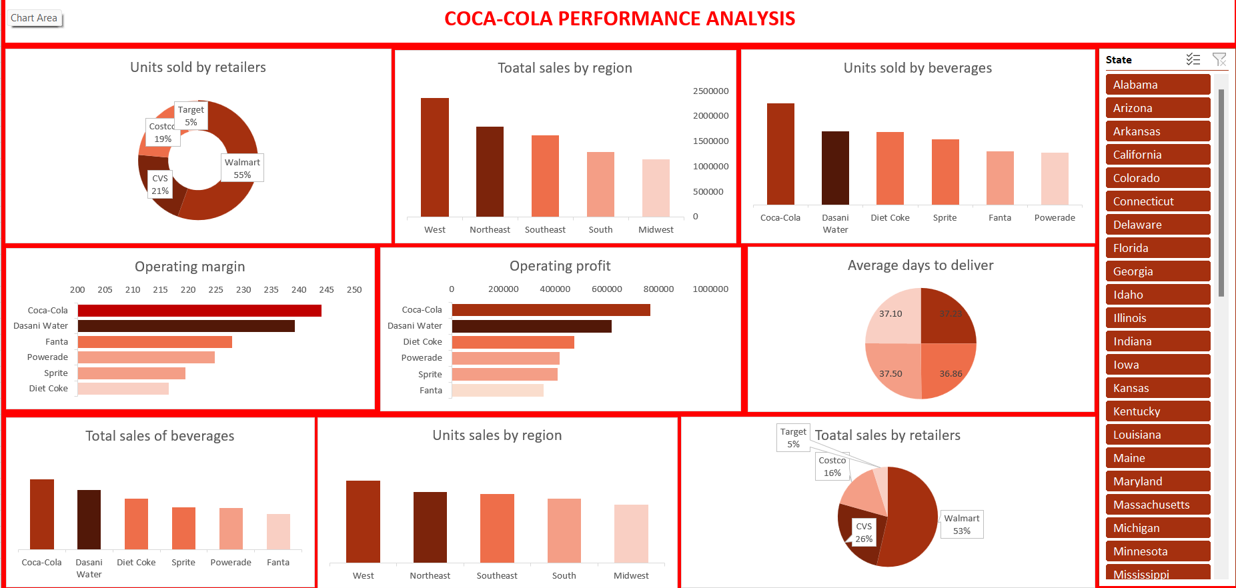

7. **Recommendations**:

• **Boost Distribution to Top Retailers:** Focus efforts on scaling supplies to Walmart, CVS, and Costco given their sales dominance.

• **Sustain and Expand Coca-Cola Production:** Given its top performance in both revenue and unit sales, Coca-Cola remains the flagship product.

• **Improve Delivery Logistics:** Analyze underperforming delivery companies and address delays, especially for high-demand products.

• **Focus Marketing in the West & Southeast:** These regions combine high unit sales with strong revenue performance.

• **Optimize Product Mix:** Consider reducing investment in lower-performing beverages and reinforcing top products in high-profit regions.

**8. Conclusion:**

This report provides a comprehensive performance overview of Coca-Cola beverages across retailers and regions for 2020. Implementing these insights will guide the business toward improved distribution strategies, profitability, and customer satisfaction.